Visual inspiration workshop

A Step by step guide

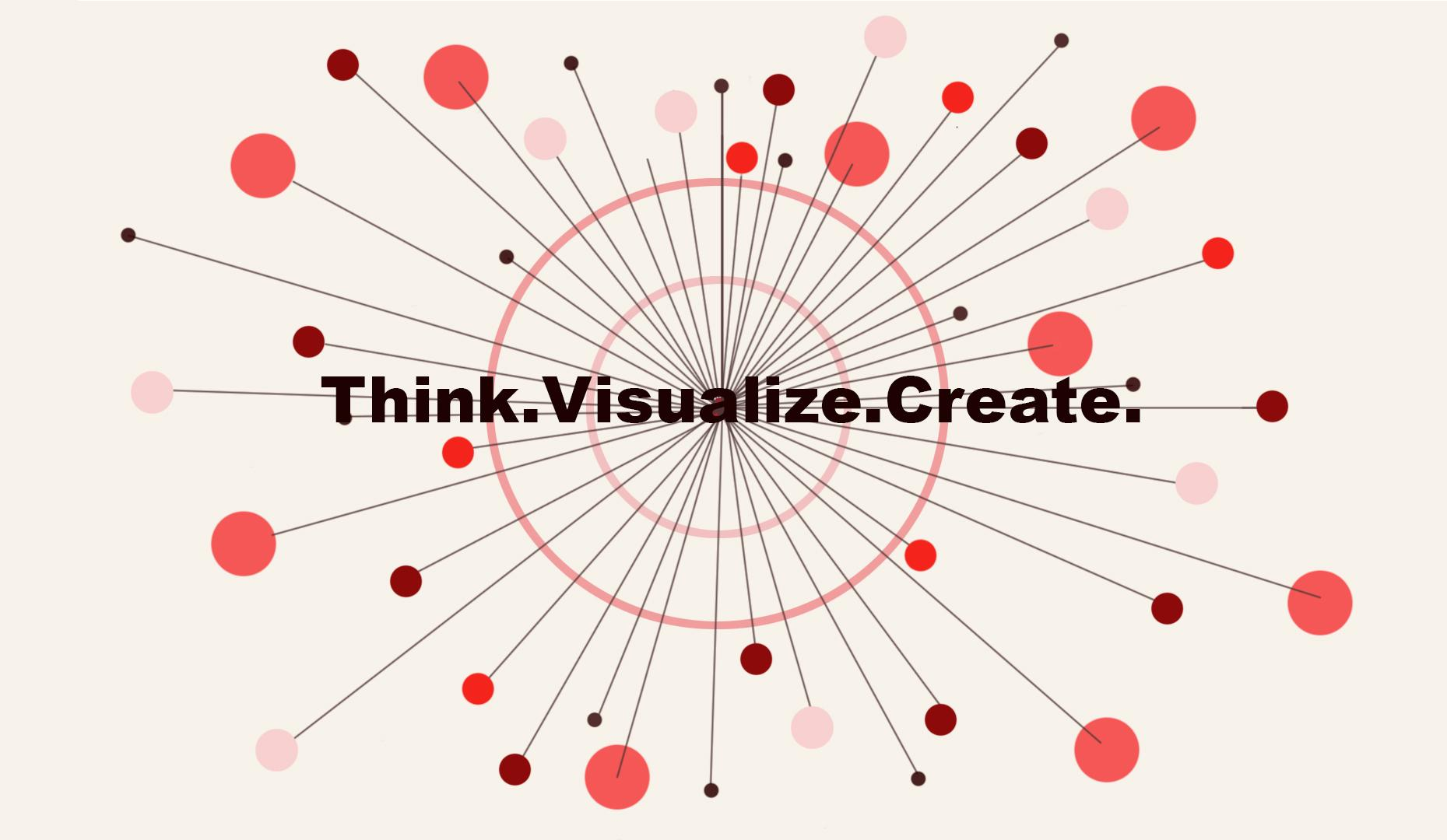

**Idit Barak**

08.03.2019

Teaching As Art/ITP/NYU

# 

# GENERAL INFORMATION

* Subtitle: learning to create a visual tool box
* Duration: 1 hour
* Recommended Number of participants: 10
* Target audience: Future Creative Professionals (e.g. Undergraduate and Graduate students in fields where visual decision making is needed)

# OBJECTIVE

# The main objective of this workshop is to familiarize those attending with an effective and practical method of going from story (subjective narrative) to a visual tool box that will assist their projects.

# MATERIALS & EXPENSES

* Slide deck (included below)
* 1 easel size (34”*27”) white paper pad $10.95
* 1 pack 24 pc. multi colored Sharpie Markers $21.89
* Bic 12 black fine tip markers $6.39

Total cost of materials $39.23

*All Materials can be found at Staples or can be substituted for similar choices

# PREPARATIONS

When preparing for this workshop be sure to remember:

* Make changes to opening slide to introduce yourself to participants.
* Roughly 10 days before the workshop create an Event Page on a platform of your choice.
* Use the descriptions provided in this document to clearly outline objectives and takeaways.
* Provide clear directions to the venue including specific floor, room etc.
* 3 days before the workshop, contact venue manager to see if an RSVP list needs to be provided in advance and be sure to close ticket sales on event page accordingly.
* If possible I highly recommend visiting the venue a few days before the day of the workshop (if not contact venue manager) to check that there is a big functioning screen, HDMI cable, ⅛” to ⅛” Audio connection and a big table with at least a dozen chairs. If you find that one of these item is not in the room make sure to arrange that they are provided or brought by you to the venue.
* On the day of the workshop make sure to:
  + Start the day by sending your guests a reminder including time & location.
  + Think about what you wear (make a visual statement about yourself).
  + Go over the slides to have them fresh in your mind.
  + Arrive at least 1 hour before to accommodate; troubleshooting, connecting your computer to check sound and slideshow running properly.

# 

# TIMELINE OF WORKSHOP

Introduce yourself- Participants introduce themselves

7 min - lecture/Historical context and need

5 min - Discussion/Where do participants find inspiration or need it?

3 min - Present exercise and answer questions

10 min - exercise/Sun of Association exercise

10 min - lecture/The different tools to identify in diagram

5 min - exercise/Color code tools on diagram

10 - Lecture/Image importance and image search with examples

10 - Discussion/Feelings about exercise and final thoughts

# 

# 

# 

# WORKSHOP DESCRIPTION & SYLLABUS

Inspiration is an essential part of the creative process but it is also a mysterious and elusive concept. This workshop will begin by attempting to define the meaning of Inspiration, from the first references in Greek mythology to the contemporary ways we think of inspiration today.

We are surrounded by endless sources of inspiration, like little threads waiting to be pulled to unravel and reveal worlds of stories and references.How do we know which thread to follow?

Regardless of the medium one chooses as a creative outlet, all visual creators need to define a set of tools before they embark on any given project.

In this workshop we will go through the steps that lead all the way up to the moment of beginning to create. Participants will discover that the process of researching, gathering inspiration and compiling it in a way that makes for a rich endless source of conceptual as well as practical visual information. The workshop will focus on the idea that In order to compile an effective “tool box” for oneself, one must research and gather information on the topic of choice with the intent of presenting a subjective point of view. This is why connecting the dots in a new, surprising and fresh way is essential. Our audience expects us to put our twist on the story we are telling because if not, it is just factual dry information.

Looking at the world subjectively is for most creators an intuitive process, but the stress to perform and output new ideas in work environments that are becoming more and more “efficient” can become a daunting task. Offering an original outlook on a subject became especially tricky with the introduction of search engines and tools like; Google Images, Pinterest, Adobe Capture etc. In this workshop we will examine ways to use these tools for our benefit rather than falling into the traps of lowest common denominator algorithmic search results. How to responsibly search the information behind an image and how to get the perfect image for the story we want to represent rather than the one chosen for us.

**Outcome/Tangible Takeaways:**

* The meaning of “inspiration” from Greek mythology to today
* An empowered approach to how we define our relationship to inspiration
* A deeper understanding of preparing a visual toolset for making
* Participants will learn how to use a sun of association brainstorm strategy
* Through detailed examples, participants will learn how to search and organize images that inspire them

**workshop syllabus (by slide #):**

***What is creative inspiration? (2-8)***

**Information - Briefly elaborate on these these points:**

* Dictionary definition
* Word origins - etymological definition
* In Greek and Roman mythology - muses, gods and demons
* The turning point, Age of Enlightenment - artist as genius

***Why do we need a tool box? (8-13)***

**Ask the group:**

* Where do you find inspiration?
* When is the last time you got stuck without inspiration?

**Knowledge/Unpack these statements:**

* Jump starting a project from intuition is not sustainable
* To gain subjectivity or unique point of view on a story
* Inspiration is all around us - Pulling Threads analogy
* Ask one group member to start from a film/show they saw and start “pulling” the thread by every group member adding a reference. If the “thread” is “dropped” meaning somebody got stuck start another. Do this 2-3 times depending on how long the thread keeps going.
* Use a cooking show analogy to iterate the importance of not only identifying your ingredients but deciding how to use them.

***Let’s fill that box (14-20)***

**Knowledge:**

* Show - Walter@Work (see reference list)
* Discuss ideas of tension and “The Opposable Mind”
* Explain a ”Sun of Associations” (show example) process, refer to “Thread Pulling”

**Experience:**

Instruct each group member to take a sheet of paper and black pen. At the center of the page, as in your example they are to write a seed word. Suggest that it can be a simple visual prompt or a keyword from a project they are currently working on. From that word they are to let their associations pour out to the page uninhibited. Check on their progress. Suggest that if they went far in one direction to try the exact opposite in order to examine tensions within the stories or threads.

**Knowledge - explain tool list;**

* Narrative as tool
* History as tool
* Culture as tool
* Color as tool
* Texture as tool
* Form as tool
* Tension as tool
* Demonstrate color coding tools to examine balance

**Experience:**

Ask group to revisit their diagrams and with different colors, circle different words that they think can serve as their different tools.

**Knowledge - demonstrate through premade examples**

* Once you have identified your ingredients, transfer words into images
* Be your own search engine- the curse of search algorithms
* It is not just the information behind the image but also the image itself
* Check your list and consider; hierarchy & layout
* Ask group how they felt about the exercise?
* Were they surprised by some of the places you reached?

# 

# REFLECTIONS/MY EXPERIENCE

I wrote this workshop because my experience at ITP made me feel there was a real need to discuss storytelling on a conceptual, visual level. As aspiring creative technologists we know we want to tell stories we are learning how to build them but we have little tools to make esthetic decisions or to explain our intuitions to ourselves and make those methodical. I thought a workshop that offers such a tool and way of thinking could be beneficial to student/young professionals in similar fields.

I think the workshop went well. I was prepared, had all the equipment checked and ready in advance, my timing was planned out correctly and I felt comfortable with the material.

I was however disappointed with the attendance. Although 7 people signed up for the workshop, only 3 showed up. I feel I should have worked harder at recruiting participants. I trusted the content to do the work because I truly believe it is beneficial and I know the tools are good and they work! I now know that if I should ever attempt to sell my own event, marketing is a huge part and something I need to improve on!!

# 

# REFERENCES

1. [Inspiration - Wikipedia’s definition](https://en.wikipedia.org/wiki/Artistic_inspiration)
2. [9 muses of Greek Mythology](https://www.greekmyths-greekmythology.com/nine-muses-in-greek-mythology/)
3. [Your Elusive Creative Genius”](https://www.greekmyths-greekmythology.com/nine-muses-in-greek-mythology/): [Elizabeth Gilbert](https://www.greekmyths-greekmythology.com/nine-muses-in-greek-mythology/)
4. [Fashion your future: Think more like a fashion designer | Suzi Vaughan | TEDxQUT](https://www.youtube.com/watch?v=NkjNxCzBUqQ)
5. [Finding your Creative Muse](https://thesecondprinciple.com/creativity/finding-your-creative-muse/)
6. [Bias within Google Image Search algorithm](https://www.quora.com/What-is-the-algorithm-behind-Google-images-Photos)
7. [walter@work](https://vimeo.com/28777015)
8. <https://www.etymonline.com/word/inspiration>
9. <https://www.amazon.com/Opposable-Mind-Successful-Integrative-Thinking-ebook/dp/B004OC077G>
10. https://www.skillshare.com/classes/Kickstart-your-Creativity-Introduction-to-Mood-Boards/213540154?via=search-layout-grid

# 

# IMAGES

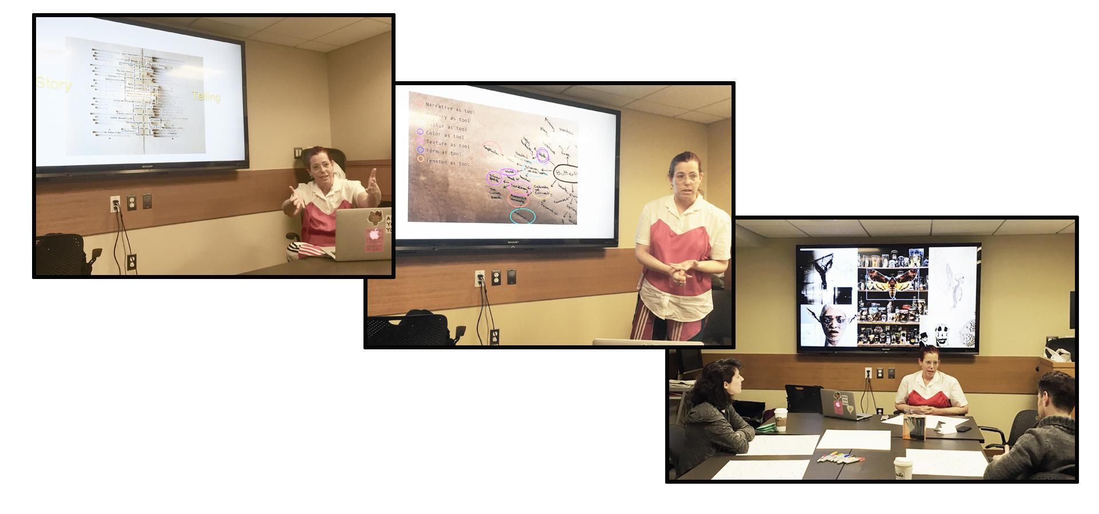

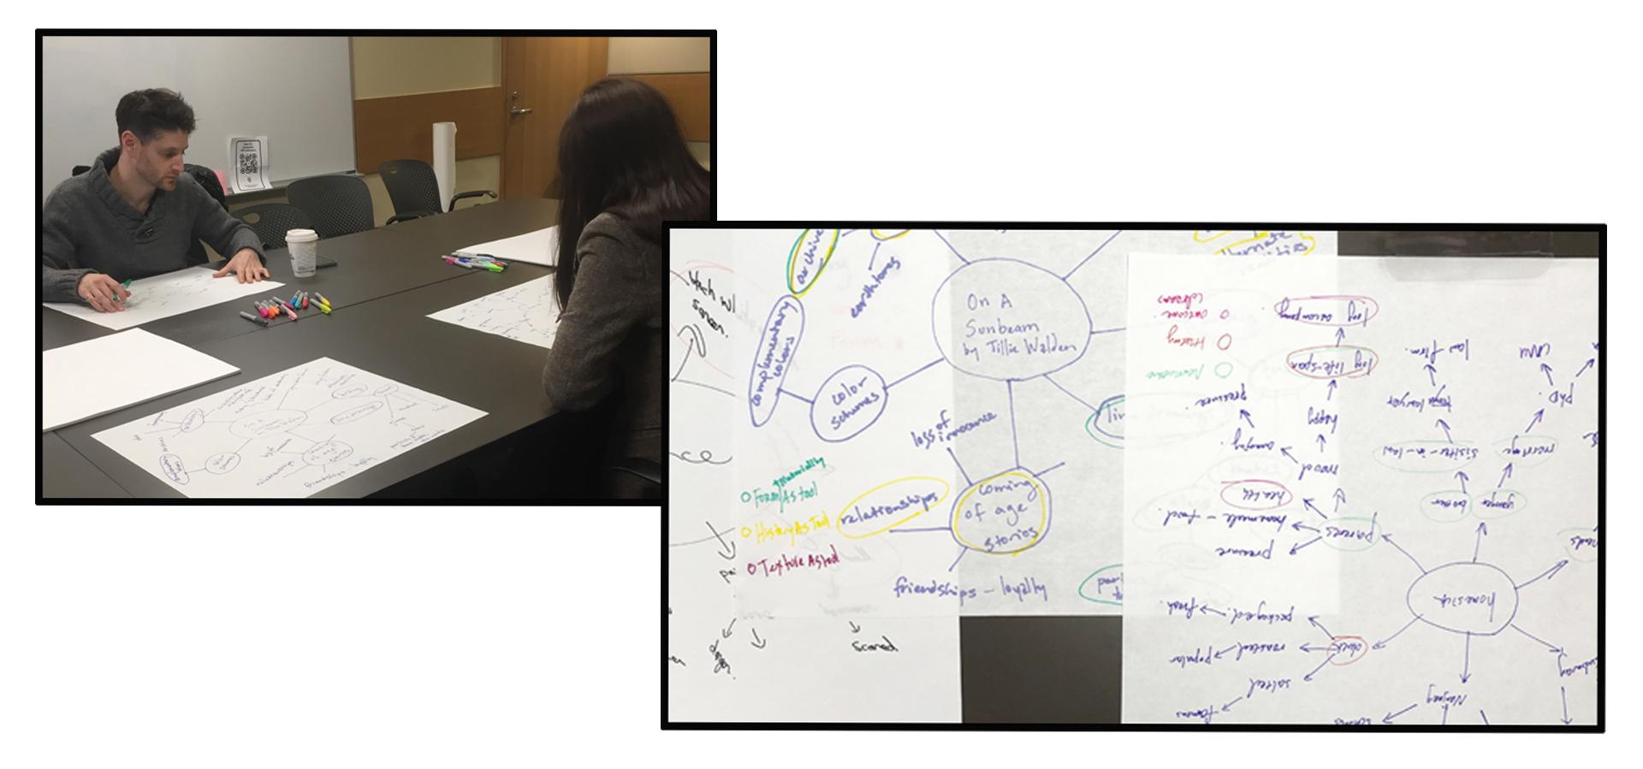Short video from workshop

<https://vimeo.com/322395953>

[slideshow of workshop for reference](https://docs.google.com/presentation/d/1tFDOdjCcbSFt0OkQ8WazQoPs7gC5rDdORm0WhyEZwTA/edit?usp=sharing)

# Participant Feedback

1.Inspiration as a tool in the Creative Process Workshop feedback:

"Where do you feel you're lacking creative (visual) inspiration?"

* I really liked how you had us introduce ourselves and share about the areas we would like to have more visual inspiration. Hearing where each attendee is coming from I think helps create a safe space, allowing vulnerability needed when really delving into the Sun of Association activity later.
* Papersize = Totally Awesome!

I really enjoyed the paper size, and found the color coding for toolsets a really empowering part of the activity. Could really imagine then how certain elements would come into play for an art piece or project.

* Really loved the sun of associations activity! / possibly add a midway checking to guarantee specificity of references

I found it really helpful when you looked at my web and after seeing the word "building" mentioning that the next step would be to list a very specific building This activity will definitely be a part of my process now onward.

Accidentally started circling other branches before we got to the tool ID step? Maybe before starting could reiterate to not circle things quite yet as a way to really get at that Sun pattern?

* Color Coding - Just found it so helpful & satisfying
* Cooking Analog = very helpful
* Seeing a final product from your portfolio + the toolkit you used to reference throughout your making process.
* You have a really great teaching presence / engaging teaching style, even though I was feeling sleepy from the day I felt very excited to try out the activities / engaged
* I Would definitely recommend workshop to a friend or colleague

2. **Inspiration as a tool in the Creative Process Workshop feedback:**

The theme was very practical: since I majored in landscape design as an undergraduate and I have worked in ux, I naturally connected this workshop with “mind map ”I used to draw. I think this is a designer's inspiration collector, and also a very effective way to sort out design ideas. It is a very useful way to improve your storytelling skills.

The example is very easy to understand and appropriate: the example with the butterfly as the divergent center of thinking, the divergent thinking that has been done, in detail: there are the images of moths in the silent lambs of abstract literature and art, and the design cases of butterfly in the field of costume design, which all give good examples of divergent thinking.

I think this presentation can be a good introduction for those who are not familiar with this concept. It clearly covers:

* Help students brainstorm and explore any idea, concept, or problem
* Facilitate better understanding of relationships and connections between ideas and concepts
* Make it easy to communicate new ideas and thought processes
* Allow students to easily recall information
* Help students take notes and plan tasks
* Make it easy to organize ideas and concepts
* Thank u for ur organization.